Test Plan

For “Amazon” Web-Application

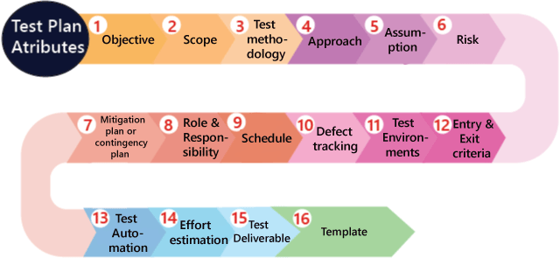

Purpose Of This Document
It is created to give an overview on what are the test cases, test scenarios, test environment we need to check. Describes the contents of the test plan (scope, objectives, test strategy, schedule, etc.). It shows who are the stakeholders who will see and use this document (QA team, developers, project managers, etc.) who will refer to the test plan.

Objective
"The objective of this test plan is to verify the functionality, performance, and security of the [Amazon] web-application. This testing effort aims to ensure that the application meets the specified business and technical requirements, is free from critical defects, and provides a seamless user experience before deployment. The testing will cover [Seller Account, Cart & Buy, login functionality], with a focus on identifying and resolving defects early in the development lifecycle."

Application Overview
The application about which we are going to write the test plan is amazon. This application is mainly used to buy and sell the products online. The target users are from age 8 to 85.It can be used as both web-based or application based.

Features overview
Amazon application will have following main feature
- Login functionality
- Buying of Goods
- Order management

Scope
In-scope
- Testing of login functionality
- Forget password option
- Seller account
- Payment and cart option

Out-scope
- Seller business details
- Accessibility testing
- Mobile-based testing

Test Methodology
The testing process will follow an Agile methodology, incorporating manual testing. Test cases will be created and executed based on user stories.

Test Environment:
- Browsers: Chrome, Firefox, Edge (latest versions)
- OS: Windows 10, macOS

Testing Scope
- Login Functionality
- Forgot Password Option
- Seller Account
- Payment and Cart Options
- Register functionality

Test Scenarios
Test Scenarios

Time Estimation

Test Planning | Day
Test Case Design | 1
Test Environment Setup | 1
Test Execution | 2
Defect Reporting & Retesting | 2
Regression Testing Test Closure | 1

Test Approach

Test Methodology
We will use agile methodology

Test Levels
- Unit Testing: Performed by developers to test individual components or functions.
- Integration Testing: Verifies the interaction between different system components.
- System Testing: Validates the complete system for functionality and performance.
- Acceptance Testing: User or client validation to ensure the system meets business requirements.

Test Environment Setup
Describes the hardware, software, network, and any dependencies that will be used during testing. For example:
- Browsers: Chrome, Firefox, Safari, etc.
- Operating Systems: Windows, macOS, Linux.
- Devices: Desktops, tablets, mobile phones (if applicable).

Test Tools
Mention the tools used for test management, test execution, and defect tracking:
- Test Management: JIRA, TestRail.

Test Completion
All planned test cases have been executed (both positive and negative).
All critical and high-priority test cases have passed.

Defect Status
All defects have been resolved or closed.
Any unresolved defects are documented, with their impact and risks assessed.
No critical or major defects remain open (optional for specific test types).

Test Coverage
Full coverage of functional and non-functional requirements.
Sufficient coverage of edge cases and boundary conditions.
Testing for all supported environments (OS, browsers, devices) is completed.

Test Cases
Test Case

